

MECHATRONICS PROJECT

SMART DUSTBIN

**TEAM – 02**

SRIRAMOJU PRAVALIKA 17K41A04H6

CHINDAM SUSHMA SREE 18K51A0422

SIVANADRI CHANDRASHEKAR 17K41A04H5

RAHUL DOMALA 17K41A04F6

**UNDER THE GUIDANCE OF**

Mr.A.Rajeshwar rao

Asst.Professor,ECE.Dept

**CONTENT**

TITLE 03

EQUIPMENT REQUIREMENT 04

PROBLEM STATEMENT 09

NEED STATEMENT 10

CONCEPT GENERATION 11

CRICRUT DIAGRAM 12

PROGRAMMING 13

**SMART DUSTBIN**

**Equipment Requirement:**

**Arduino UNO**

Arduino is an open source, computer hardware and software company, project, and user community that designs and manufactures microcontroller kits for building digital devices and interactive objects that can sense and control objects in the physical world

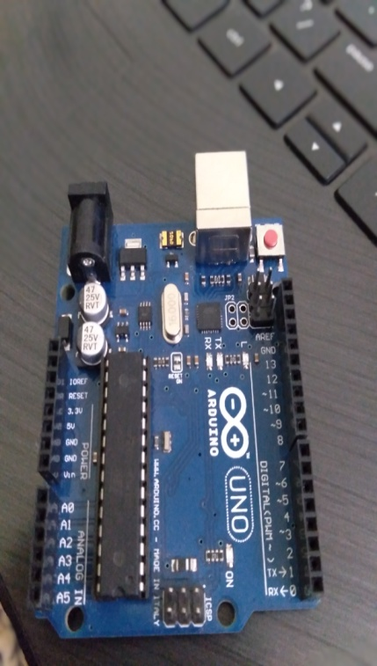

Arduino/Genuino Uno is a microcontroller board based on the ATmega328P. It has 14 digital input/output pins (of which 6 can be used as PWM outputs), 6 analog inputs, a 16 MHz quartz crystal, a USB connection, a power jack and a reset button. It contains everything needed to support themicrocontroller; simply connect it to a computer with a USB cable or power it with a AC-to-DC adapter or battery to get started.

* 3.3V (6) − Supply 3.3 output volt
* 5V (7) − Supply 5 output volt
* Most of the components used with Arduino board works fine with 3.3 volt and 5 volt. GND (8)(Ground) − There are several GND pins on the Arduino, any of which can be used to ground your circuit.
* Vin (9) − This pin also can be used to power the Arduino board from an external power source, like AC mains power supply.

**Gsm 900A module**

GSM Modem can accept any GSM network operator SIM card and act just like a mobile phone with its own unique phone number.

Applications like SMS Control, data transfer, remote control and logging can be developed easily using gsm. The modem can either be connected to PC serial port directly or to any microcontroller through MAX232. It can be used to send and receive SMS or make/receive voice calls.

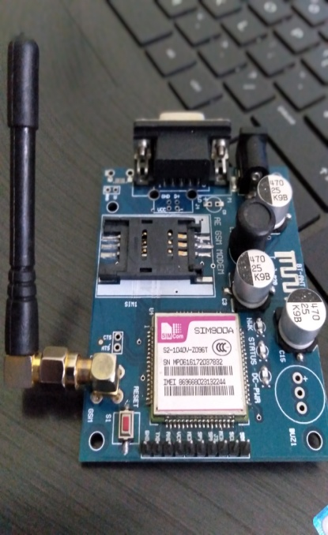

This GSM modem is a highly flexible plug and play quad band SIM900A GSM modem for direct and easy integration to RS232 applications. Supports features like Voice, SMS, Data/Fax, GPRS and integrated TCP/IP stack.

**Ultrasonic sensor**

The HC-SR04 ultrasonic sensor uses SONAR to determine the distance of an objects. It offers excellent non-contact range detection with

high accuracy and stable readings in an easy-to-use package from 2 cm to 400 cm.

The operation is not affected by sunlight or black material, although acoustically, soft materials like cloth can be difficult to detect. It comes complete with ultrasonic transmitter and receiver module.

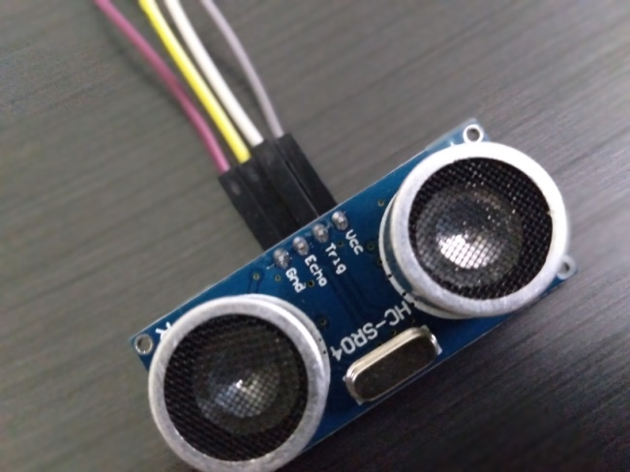

Technical Specifications:

* Power Supply − +5V DC
* Working Current − 15mA
* Ranging Distance − 2cm – 400 cm/1″ – 13ft
* Resolution − 0.3 cm
* Measuring Angle − 30 degree

**LED’s(3_Red,Yellow,Green) & Jumper wires**

A **light-emitting diode** (**LED**) is a [semiconductor](https://en.wikipedia.org/wiki/Semiconductor) [light source](https://en.wikipedia.org/wiki/Light_source) that emits light when [current](https://en.wikipedia.org/wiki/Electric_current) flows through it. [Electrons](https://en.wikipedia.org/wiki/Electron) in the semiconductor recombine with [electron holes](https://en.wikipedia.org/wiki/Electron_hole), releasing energy in the form of [photons](https://en.wikipedia.org/wiki/Photon). This effect is called [electroluminescence](https://en.wikipedia.org/wiki/Electroluminescence). The color of the light is determined by the energy required for electrons to cross the  of the semiconductor. White light is obtained by using multiple semiconductors or a layer of light-emitting phosphor on the semiconductor device.

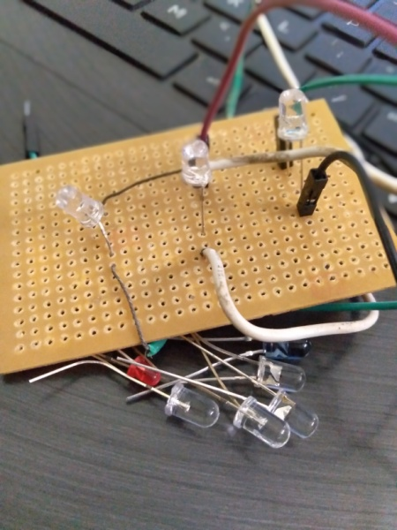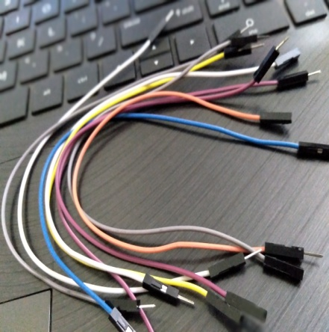

**Arduino IDE**

Programming software:

void setup() {

// put your setup code here, to run once:

}

void loop() {

// put your main code here, to run repeatedly:

}

**PROBLEM STATEMENT:**

* Usually when the dustbin are filled up totally... People would choose to throw the trash around the dustbin.. These might lead to untidy and due to the smell of the trash the people may feel insecure to walk over their and may get some sort of mild diseases.
* Over flow of bins which spread diseases.

**NEED STATEMENT:**

* Govt. of india and public plays the major role to keep india clean and green.
* As P.M Narendra modi had started the swachh bharath this is not upto the mark in the case of public dustbins.
* To implement a smart bin built on a microcontroller based platform Arduino Uno board which is interfaced with GSM modem and Ultrasonic sensor which can gives the status of the waste present in the dustbin to the municipal authority.

**CONCEPT GENERATION:**

* Our concept is to clean the dustbin when it is filled. So here we are using a ultrasonic sensor to detect the whether the dustbin is filled or not. When the dustbin is filled, it's senses and the red led glows. Here we use GSM(Gobal system for moblie communication) module for transferring the information to the municipal corporation. When the red led glows, the GSM module sends the text message to the municipal corporation that “The bin is filled, Go clean the bin.” Then the municipal corporation receives the message and cleans the bin.

**CIRCUIT DIAGRAM:**

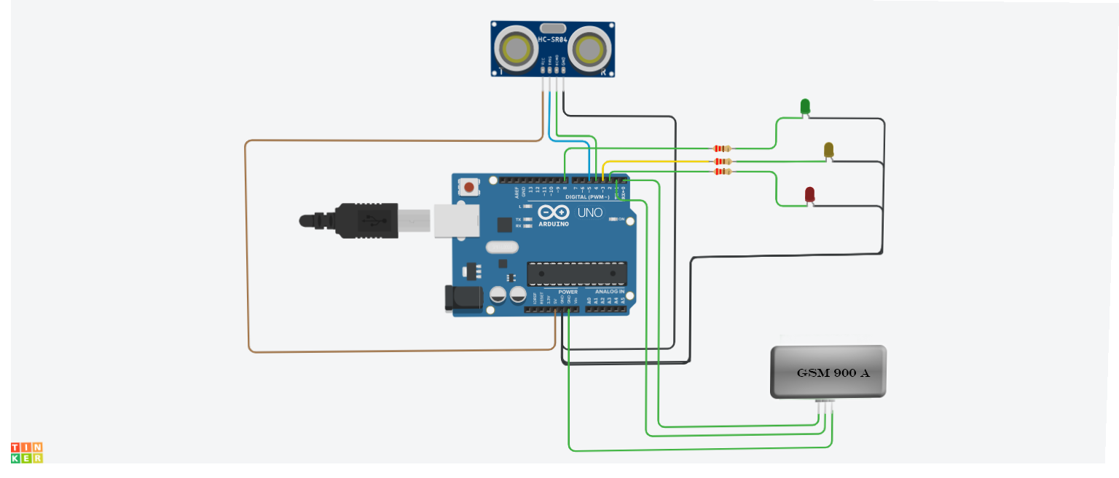

**PROGRAM**

#include <SoftwareSerial.h>

SoftwareSerial mySerial(9, 10);

int trigPin=5;

int echoPin=4;

long duration;

int distance;

void setup()

{

pinMode(8,OUTPUT);//g

pinMode(3,OUTPUT);//y

pinMode(9,OUTPUT);//r

pinMode(trigPin, OUTPUT);

pinMode(echoPin, INPUT);

Serial.begin(9600);

}

void loop()

{

digitalWrite(trigPin, LOW);

delayMicroseconds(2);

digitalWrite(trigPin, HIGH);

delayMicroseconds(10);

digitalWrite(trigPin, LOW);

duration = pulseIn(echoPin,HIGH);

distance= duration*0.0344/2;

Serial.println(distance);

delay (1000);

if(distance>10)

{

digitalWrite(8,1);

digitalWrite(9,0);

digitalWrite(3,0);

}

else if (distance<=2)

{

digitalWrite(3,0);

digitalWrite(9,1);

digitalWrite(8,0);

mySerial.println("AT+CMGF=1");//Sets the GSM Module in Text Mode

delay(1000); // Delay of 1 second

mySerial.println("AT+CMGS=\"+918328528973\"\r"); // mobile number

delay(1000);

mySerial.println("HELLO THIS IS GSM MODULE 900A, BIN NO:0141 IS FILLED PLZ CLEAN IT.TQX..!");// SMS text.

delay(100);

mySerial.println((char)26);// ASCII code of CTRL+Z for saying the end of sms to the module

delay(1000);

}

else

{

digitalWrite(3,1);

digitalWrite(8,0);

digitalWrite(9,0);

}

}